727721EUIT151

DAY_07

1

package com.Test.Test;

//import static org.testng.AssertJUnit.assertTrue;

import org.openqa.selenium.WebDriver;

import org.openqa.selenium.chrome.ChromeDriver;

import org.openqa.selenium.chrome.ChromeOptions;

import org.testng.Assert;

import org.testng.annotations.Test;

import io.github.bonigarcia.wdm.WebDriverManager;

/**

* Unit test for simple App.

*/

public class AppTest

{

/**

* Rigorous Test :-)

*/

*@Test*

public void shouldAnswerWithTrue()

{

ChromeOptions co=new ChromeOptions();

co.addArguments("--remote-allow-origins=*");

WebDriverManager.*chromedriver*().setup();

WebDriver driver=new ChromeDriver(co);

driver.get("https://demo.wpeverest.com/user-registration/guest-registration-form/");

driver.manage().window().maximize();

String actual=driver.getTitle();

String expected="Guest Registration Form – User Registration";

Assert.*assertEquals*(actual,expected);

}

}

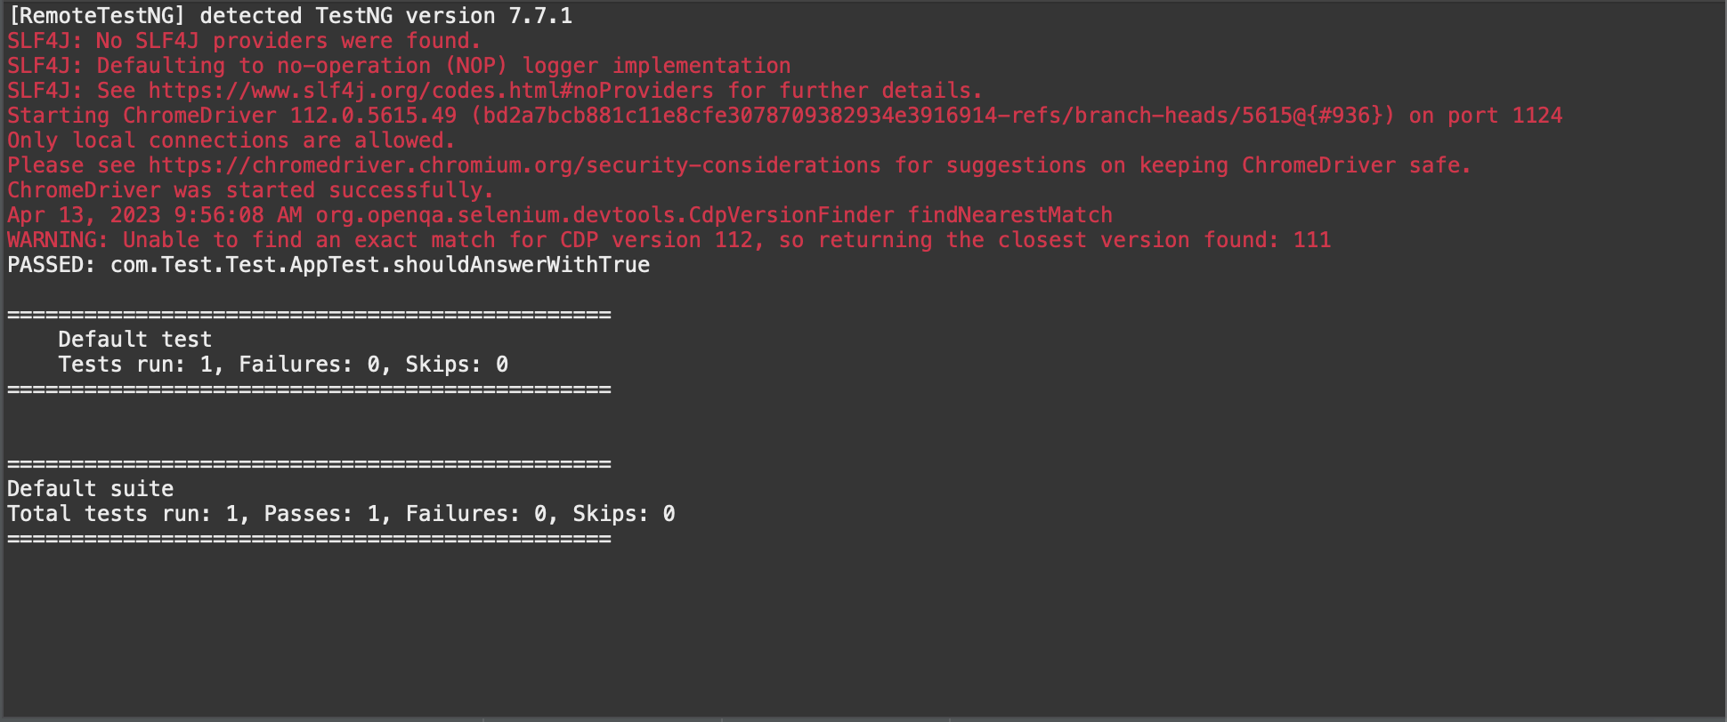

2

package com.Test.Test;

import org.testng.Assert;

import org.testng.annotations.Test;

public class Calculator {

int a=10;

int b=20;

*@Test*(priority=1)

RUN | DEBUG

public void add() {

int actual=a+b;

int expected=30;

Assert.*assertEquals*(actual,expected);

System.***out***.println("ADDED");

}

*@Test*(priority=2)

RUN | DEBUG

public void sub() {

int actual1=b-a;

int expected1=10;

Assert.*assertEquals*(actual1,expected1);

System.***out***.println("SUBTRACTED");

}

*@Test*(priority=3)

RUN | DEBUG

public void mul() {

int actual2=a*b;

int expected2=200;

Assert.*assertEquals*(actual2,expected2);

System.***out***.println("MULTIPLIED");

}

*@Test*(priority=4)

RUN | DEBUG

public void div() {

int actual3=b/a;

int expected3=2;

Assert.*assertEquals*(actual3,expected3);

System.***out***.println("DIVIDED");

}

}

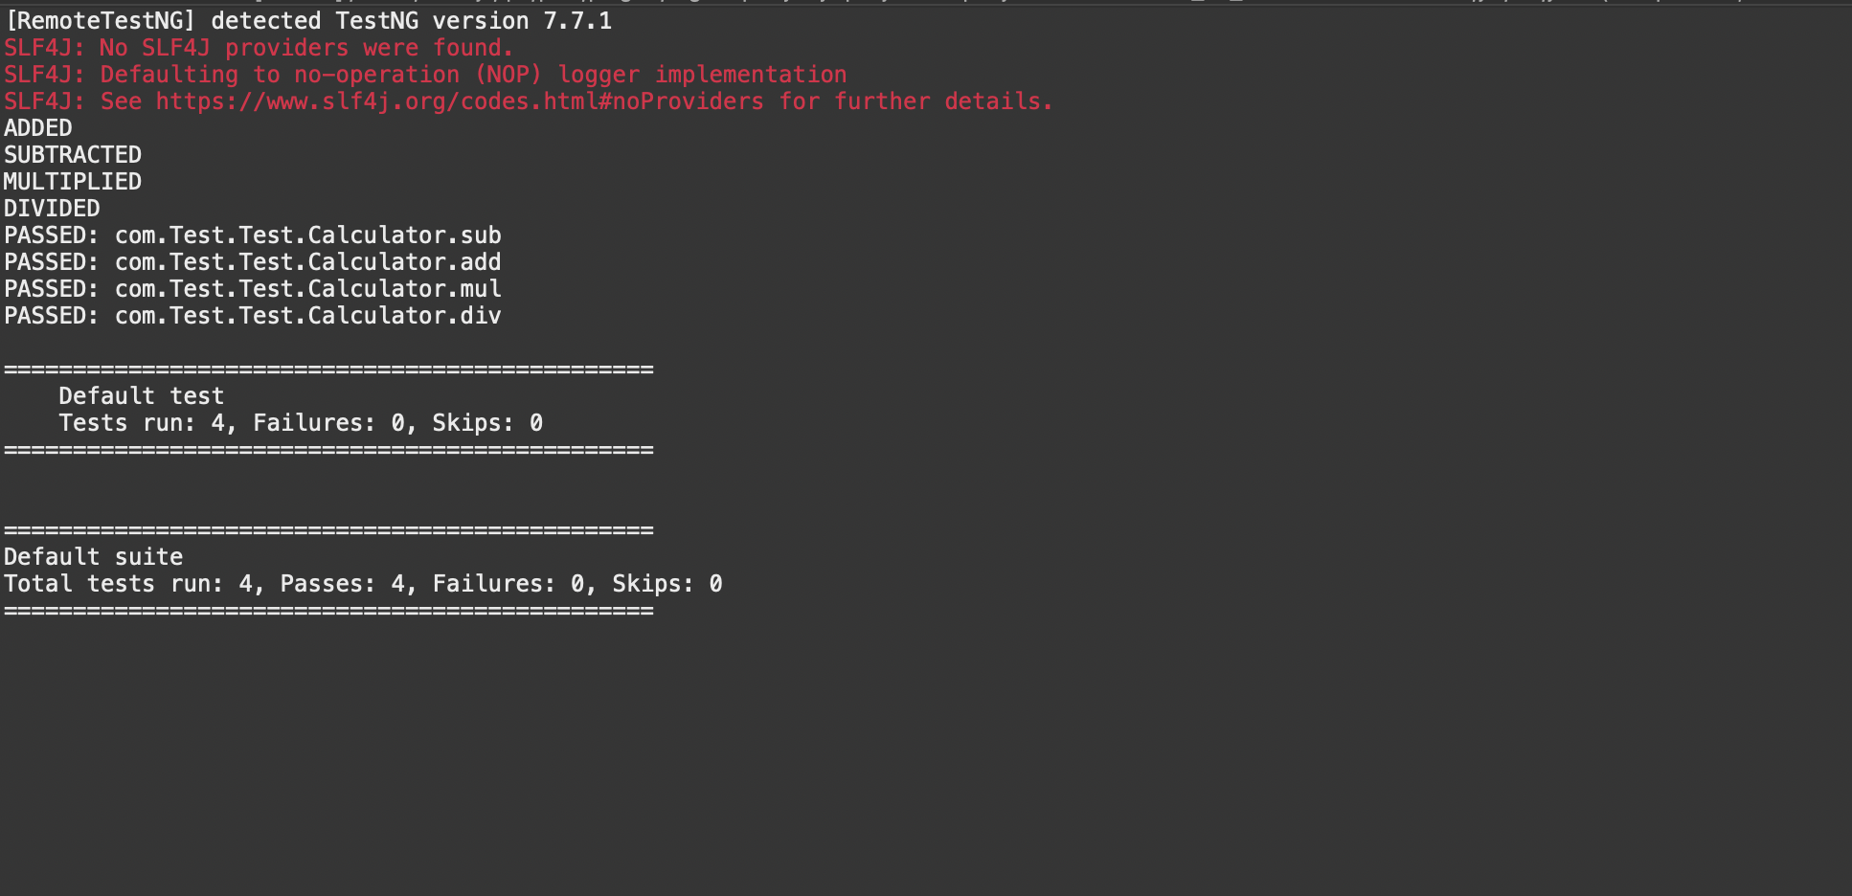

3

package com.Test.Test;

import org.testng.annotations.Test;

import io.github.bonigarcia.wdm.WebDriverManager;

import org.testng.annotations.BeforeMethod;

import org.openqa.selenium.By;

import org.openqa.selenium.WebDriver;

//import org.openqa.selenium.WebElement;

import org.openqa.selenium.chrome.ChromeDriver;

import org.openqa.selenium.chrome.ChromeOptions;

import org.testng.Assert;

//import org.testng.Assert;

import org.testng.annotations.AfterMethod;

public class ZestTest {

WebDriver driver;

*@Test*

public void print() throws InterruptedException {

driver.get("https://opensource-demo.orangehrmlive.com/web/index.php/auth/login");

Thread.*sleep*(3000);

driver.findElement(By.*xpath*("//input[@name='username']")).sendKeys("Admin");

driver.findElement(By.*xpath*("//input[@name='password']")).sendKeys("admin123");

driver.findElement(By.*xpath*("//*[@id=\"app\"]/div[1]/div/div[1]/div/div[2]/div[2]/form/div[3]/button")).click();

Thread.*sleep*(3000);

String text=driver.findElement(By.*xpath*("//h6[@class=\'oxd-text oxd-text--h6 oxd-topbar-header-breadcrumb-module\']")).getText();

String expText="Dashboard";

Assert.*assertEquals*(text, expText);

}

*@BeforeMethod*

public void beforeMethod() {

ChromeOptions co=new ChromeOptions();

co.addArguments("--remote-allow-origins=*");

WebDriverManager.*chromedriver*().setup();

driver=new ChromeDriver(co);

}

*@AfterMethod*

public void afterMethod() {

driver.close();

}

}

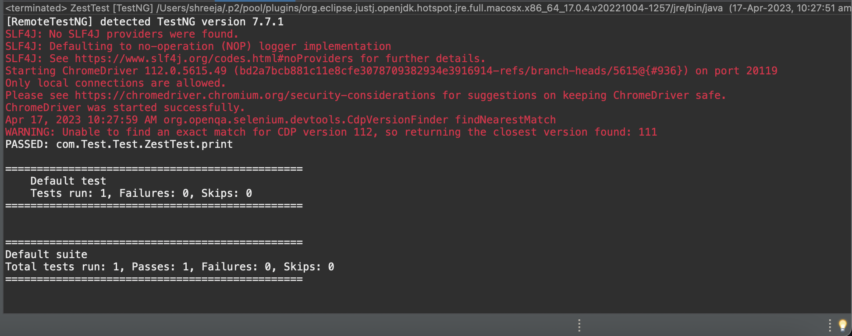

4

package com.Test.Test;

import org.openqa.selenium.By;

import org.openqa.selenium.WebDriver;

import org.openqa.selenium.chrome.ChromeDriver;

import org.openqa.selenium.chrome.ChromeOptions;

import org.testng.Assert;

import org.testng.annotations.Test;

import io.github.bonigarcia.wdm.WebDriverManager;

public class CE4 {

WebDriver driver;

*@Test*(priority=1)

public void Login() throws InterruptedException {

ChromeOptions co=new ChromeOptions();

co.addArguments("--remote-allow-origins=*");

WebDriverManager.*chromedriver*().setup();

driver=new ChromeDriver(co);

driver.get("https://opensource-demo.orangehrmlive.com/web/index.php/auth/login");

driver.manage().window().maximize();

Thread.*sleep*(3000);

driver.findElement(By.*xpath*("//input[@name='username']")).sendKeys("Admin");

driver.findElement(By.*xpath*("//input[@name='password']")).sendKeys("admin123");

driver.findElement(By.*xpath*("//*[@id=\"app\"]/div[1]/div/div[1]/div/div[2]/div[2]/form/div[3]/button")).click();

Assert.*assertEquals*(driver.getCurrentUrl(),"https://opensource-demo.orangehrmlive.com/web/index.php/dashboard/index");

}

*@Test*(priority=2, dependsOnMethods=("Login"))

public void Logout() throws InterruptedException {

Thread.*sleep*(3000);

driver.findElement(By.*xpath*("//span[@class=\"oxd-userdropdown-tab\"]")).click();

Thread.*sleep*(3000);

driver.findElement(By.*xpath*("//ul[@class=\"oxd-dropdown-menu\"]/li[4]/a")).click();

Assert.*assertEquals*(driver.getCurrentUrl(),"https://opensource-demo.orangehrmlive.com/web/index.php/auth/login");

}

}

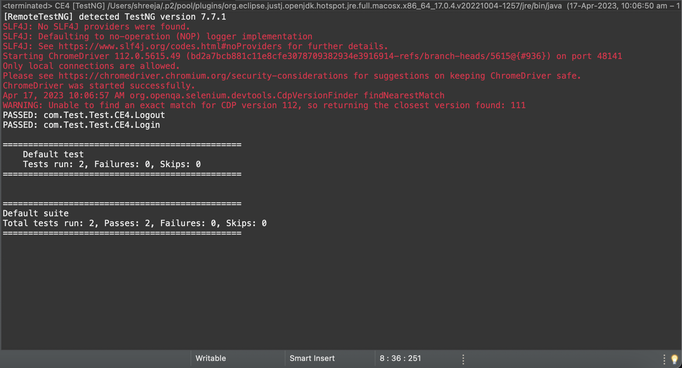

5

package com.Demo.Demo;

import org.testng.annotations.Test;

import io.github.bonigarcia.wdm.WebDriverManager;

import org.testng.annotations.BeforeMethod;

import java.util.concurrent.TimeUnit;

import org.openqa.selenium.By;

import org.openqa.selenium.WebDriver;

import org.openqa.selenium.chrome.ChromeDriver;

import org.openqa.selenium.chrome.ChromeOptions;

import org.testng.Assert;

import org.testng.annotations.AfterMethod;

public class d75

{

WebDriver d;

@Test(groups=&quot;Smoke Test&quot;)

public void t1()

{

String eurl=&quot;https://www.godaddy.com/en-in&quot;;

String curl=d.getCurrentUrl();

Assert.assertEquals(eurl,curl);

String etitle=&quot;Domain Names, Websites, Hosting &amp; Online Marketing Tools - GoDaddy IN&quot;;

String ctitle=d.getTitle();

Assert.assertEquals(etitle,ctitle);

}

@Test(groups=&quot;Regression Test&quot;)

public void t2()

{

d.manage().timeouts().implicitlyWait(10,TimeUnit.SECONDS);

d.findElement(By.xpath(&quot;//*[@id=\&quot;id-631b049a-e9c0-4d24-8710-

c504745206dd\&quot;]/div[2]/div[1]/ul/li[1]/button&quot;)).click();

d.findElement(By.xpath(&quot;//*[@id=\&quot;id-631b049a-e9c0-4d24-8710-

c504745206dd\&quot;]/div[2]/div[1]/ul/li[1]/div/div[2]/div[1]/ul/li[2]/a&quot;)).click();

}

@Test(groups=&quot;Regression Test&quot;)

public void t3()

{

d.manage().timeouts().implicitlyWait(10,TimeUnit.SECONDS);

d.findElement(By.xpath(&quot;//*[@id=\&quot;id-631b049a-e9c0-4d24-8710-

c504745206dd\&quot;]/div[2]/div[1]/ul/li[1]/button&quot;)).click();

d.findElement(By.xpath(&quot;//*[@id=\&quot;id-631b049a-e9c0-4d24-8710-

c504745206dd\&quot;]/div[2]/div[1]/ul/li[1]/div/div[2]/div[1]/ul/li[2]/a&quot;)).click();

String ctitle=d.getTitle();

String etitle=&quot;GoDaddy Domain Search - Buy and Register Available Domain Names&quot;;

System.out.println(ctitle);

Assert.assertEquals(etitle, ctitle);

}

@BeforeMethod

public void beforeMethod()

{

ChromeOptions co=new ChromeOptions();

co.addArguments(&quot;--remote-allow-origins=*&quot;);

WebDriverManager.chromedriver().setup();

d=new ChromeDriver(co);

d.get(&quot;https://www.godaddy.com/en-in&quot;);

d.manage().window().maximize();

}

@AfterMethod

public void afterMethod()

{

d.close();

}

}

